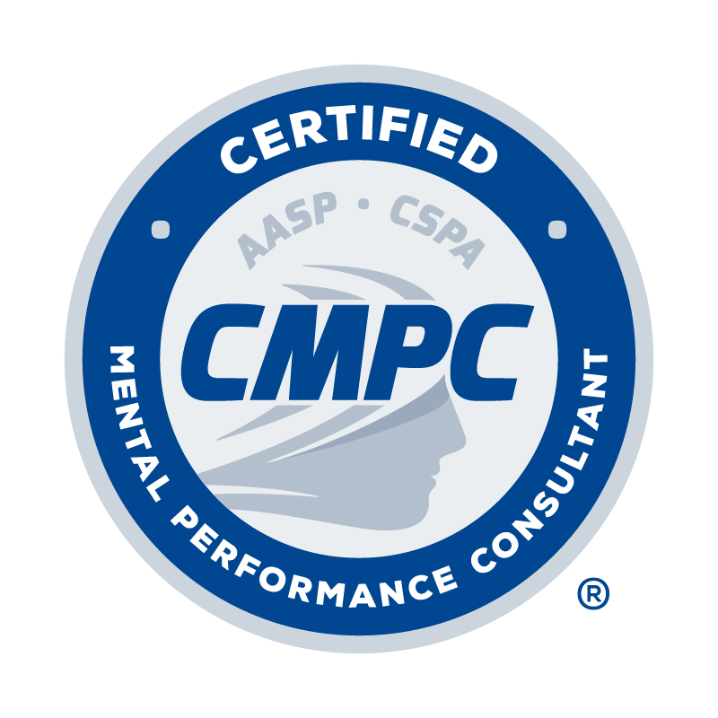

REGISTRY OF APPROVED MENTORS
RENEWAL FORM
(for non-CMPC mentors)

Application Date: (Applications will only be accepted after September 1 in the renewal year).

To maintain listing in the Registry, non-CMPC mentors are required to renew their registration every 5 years and complete a minimum of 15 CEUs in professional practice areas, including 6 CEUs in the areas of mentorship/supervision.

I. PERSONAL INFORMATION

Last Name: First Name: Middle Initial:

Current Affiliation and Position:

Home Address: check if preferred mailing address Business Address: check if preferred mailing address
Home Phone: | Business Phone:

Email Address:

II. CONTINUING EDUCATION (CE) ACTIVITY LOG

Complete the Continuing Education Activity Log by following the instructions provided below. Refer to the Candidate Handbook for requirements related to continuing education units (CEUs) for approved mentors.
- Type of CE Activity: Select the type of CE activity completed from the drop-down menu. Options include Conference, Webinar, Presentation, Workshop, Academic activity. Refer to the Candidate Handbook for descriptions of acceptable CE activities.
- Name of CE Activity: Record the title of session/activity completed.
- Hosting Organization: Record the organization that hosted the CE activity.
- Date: Record the date the CE activity occurred.
- # of CEUs: Record the number of CEUs awarded for each activity. Refer to the Candidate Handbook for information regarding the number of CEUs awarded for various activities.
Provide documentation as evidence of completion for each CE activity as outlined in the CE Activity table provided in the Candidate Handbook. Documentation is required for each CE activity as indicated in the CE Activity table.

TYPE OF  CE ACTIVITY | NAME OF CE ACTIVITY | HOSTING ORGANIZATION | DATE | # of CEUs
Webinar | Best Practices in Supervision for Developing Competent Consultants | AASP | July 2020 | 1.25
TOTAL # OF CEUs |  |  |  | 0.00

III. ATTESTATION AND ETHICAL CODE

I have read and understand the CMPC® Certification Program Candidate Handbook, especially the Mentored Experience Requirements outlined in Section One, and agree to abide by the policies of the Certification Council and AASP as described therein, including the confidentiality and disciplinary rules. I understand that the information I provide to the Certification Council may be audited, and I authorize the Council to make any necessary inquiries in this regard.

By applying for renewal in listing in the Registry of Approved Mentors, I agree to adhere to the AASP Ethics Code and to having read the CMPC® Mentor Guidelines and Best Practice Recommendations. I understand that any violation of any portion of the AASP Ethics Code may result in disciplinary action as outlined in the Disciplinary and Complaints Policy of the Candidate Handbook.

I certify that the information contained in this renewal application for inclusion in the Registry of Approved Mentors is true, complete, and correct to the best of my knowledge. I understand that the submission of false or misleading information at any time may be the cause for revocation of this application and/or listing in the Registry, without refund of any fees.

Signature of Applicant Date

To submit application:

- Combine and convert the completed application form and curriculum vitae/resume into a single PDF.

Email PDF to Leilani Madrigal, PhD, CMPC, Mentoring Committee Chair, at Leilani.madrigal@csulb.edu with the subject line “Registry Application_First Initial Last Name

