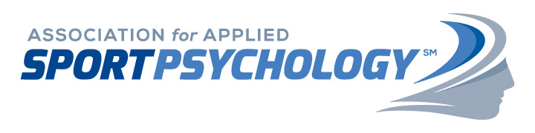
Petition for Reinstatement after
Violation of AASP Code of Ethics
Persons whose AASP membership has been revoked may petition the Ethics Committee for reinstatement at the completion of the revocation period. The Ethics Committee will review petitions for reinstatement that are fully complete and have been received at least 30 days prior to the Ethics Committee’s next scheduled meeting. Petitions that have been received less than 30 days prior to a scheduled meeting will be held until the next scheduled meeting. The reinstatement process may take several months, depending on the submission date and the date of the next Ethics Committee meeting. Please refer to the “Preparing Your Statement” guidelines on page 2 of this document.

Ethics Committee deliberations are guided by the premise that reinstatement must be in the best interests of the Association for Applied Sport Psychology (AASP) and those persons who will be served professionally. The Ethics Committee may set any reinstatement condition or requirement it deems necessary for the protection and benefit of the public and the professions. Petitioners who receive a Reinstatement Order must meet all AASP certification standards and membership requirements that are in effect at the time.

Please complete the following information:

Date _____________________
Case # ____________________ Term of Revocation __________________
Effective Date _______________ Expiration Date _____________________
Applicant Name ____________________________
Address _________________________________
Telephone __________________ E-mail _________________________

Office Use Only:
Applicant AASP Member ID ______________________________
Ethics Committee meeting date: __________________

Preparing Your Statement

You, the petitioner, bear the burden of demonstrating with appropriate documentation that the conditions that led to the revocation of your membership and certification have been rectified and that upon reinstatement you will abide by the AASP Code of Ethics.

Information related to the following should be included in your petition for reinstatement, where applicable:
• Explain how restitution was made for the action(s) that led to the revocation.
• Provide an acknowledgment of your wrongdoing/problem that resulted in the revocation.
• Explain how you have been rehabilitated.
• Explain how you are maintaining and continuing to manage your corrective action.
• Provide evidence of continuing education and/or training completed related to the action(s) that led to revocation.
• Provide a statement related to your current licensing status (include a copy of your license) if applicable.
• Explain how you will continue to abide by the AASP Code of Ethics.
• Include all supporting documentation related to the statements in your petition.

Affirmation
[ ] I have enclosed a written statement petitioning for reinstatement.
[ ] I have enclosed documentation supporting the statements in my petition.
[ ] I affirm that the statements and information in my petition are complete and truthful.
____________________________________________________
Signature
____________________
Date

Send petition and accompanying documentation in an envelope marked CONFIDENTIAL to:

AASP Ethics Committee Chair
c/o AASP
8365 Keystone Crossing, Suite 107
Indianapolis, IN 46240

For general questions about the process of petitioning for reinstatement, please contact the current Ethics Committee chairperson listed at:
http://www.appliedsportpsych.org/about/aasp-committees/ethics-committee/

